
Name: Akshitha.S course:Data structure
Course code: CSA0313
Register no: 192521390

- How to add new node at the begining of the list
To add a new node at the beginning (head) of a singly linked list
- First, create a new node using dynamic memory allocation.
- Store the required data value inside the new node.
- The next pointer of the new node is connected to the current head node.
- Update the head pointer so that it points to the new node.
- Now, the new node becomes the first node in the linked list.
- This operation is fast because we do not need to travel through the entire list.

Step 1: Initial Linked List State
Initially, the head points to the first node in the list (Node A at memory address 0x1000).
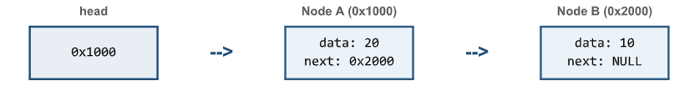
Step 2: Allocate &amp; Connect New Node
1. Allocate memory for ‘new_node’ (e.g. at address 0x0500) and set data = 30.
2. Set new_node-&gt;next = head (points new node to Node A at 0x1000).
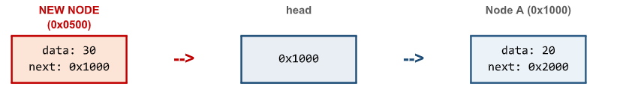
Step 3: Update Head Pointer (Final State)
Update head = new_node (*head_ref = new_node). The new node is now officially the first node of the list.
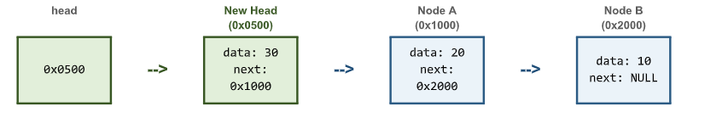
Code to add new node at the begining of the list
#include <stdio.h>
#include <stdlib.h>
struct Node {
int data;
struct Node* next;
};
void insertAtBeginning(struct Node** head, int newData) {
struct Node* newNode = (struct Node*)malloc(sizeof(struct Node));
newNode->data = newData;
newNode->next = *head;
*head = newNode;
}
void printList(struct Node* head) {
while (head != NULL) {
printf("%d -> ", head->data);
head = head->next;
}
printf("NULL\n");
}
int main() {
struct Node* head = NULL;
insertAtBeginning(&head, 10);
insertAtBeginning(&head, 20);
insertAtBeginning(&head, 30);
printList(head);
return 0;
}
2 .To find the length of the list
- Start from the head node of the linked list.
- Initialize a counter variable to 0.
- Traverse the list using the next pointer.
- Increase the counter by 1 for each node visited.
- Stop when the pointer reaches NULL.
- The counter value gives the length of the linked list.
Linked List Diagram

10 | → | 20 | → | 30 | → | NULL
Node1 |  | Node 2 |  | Node 3 |  | End
Length = 3 nodes

Code for finding the length

#include <stdio.h>
struct Node {
int data;
struct Node *next;
};
int main() {
struct Node n1, n2, n3;
int count = 0;
n1.data = 10;
n2.data = 20;
n3.data = 30;
n1.next = &n2;
n2.next = &n3;
n3.next = NULL;
struct Node *temp = &n1;
while (temp != NULL) {
count++;
temp = temp->next;
}
printf("Length = %d", count);
return 0;
}

3.How to display or print the data ?
- Start from the head node.
- Access the data in each node.
- Print the data using printf().
- Move to the next node using next.
- Continue until NULL is reached.
Code to display data
#include <stdio.h>
struct Node {
int data;
struct Node *next;
};
int main() {
struct Node a = {10, NULL};
struct Node b = {20, NULL};
struct Node c = {30, NULL};
a.next = &b;
b.next = &c;
struct Node *temp = &a;
while (temp != NULL) {
printf("%d ", temp->data);
temp = temp->next;
}
return 0;
}
Step-by-Step Diagram
STEP 1 | HEAD | Start
STEP 2 | [ 10 | • ] | Read 10
STEP 3 | Print → 10 | Display 10
STEP 4 | [ 20 | • ] | Move to next
STEP 5 | Print → 20 | Display 20
STEP 6 | [ 30 | NULL ] | End

Final Output: 10 20 30
4.Tower of Hanoi
- Tower of Hanoi is a puzzle with three rods and n disks.
- Move all disks from the source rod to the destination rod.
- Only one disk can be moved at a time.
- A larger disk cannot be placed on a smaller disk.
- The problem is solved using recursion.

Code for tower of Hanoi

#include<stdio.h>
void hanoi(int n,char from,char to,char aux){
if(n==1){
printf("Move disk 1 from %c to %c\n",from,to);
return;
}
hanoi(n-1,from,aux,to);
printf("Move disk %d from %c to %c\n",n,from,to);
hanoi(n-1,aux,to,from);
}
int main(){
hanoi(3,'A','C','B');
return 0;
}

Tower of Hanoi Diagram
Initial Position – 3 Disks
| | | | |
[1] | | | |
[ 2 ] | | | |
[ 3 ] | | | |
====== | ====== | =======
A B C
Source Auxiliary Destination
Goal: Move all disks from A to C
Final Position – 3 Disks
| | | | |
| | | | [1]
| | | | [ 2 ]
| | | | [ 3 ]
======= | ======= | =======
A B C
Source Auxiliary Destination

